Lab 5
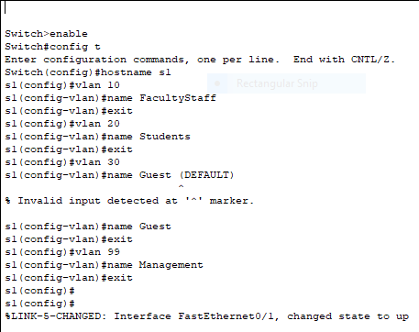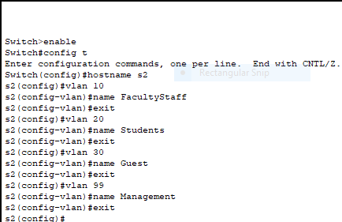
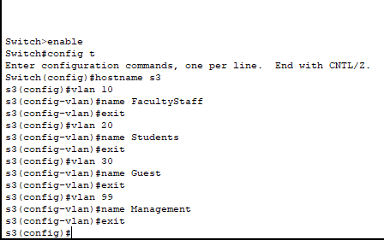
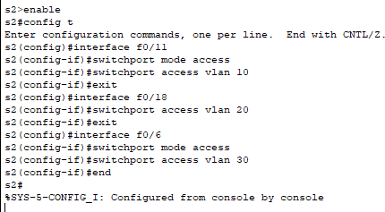

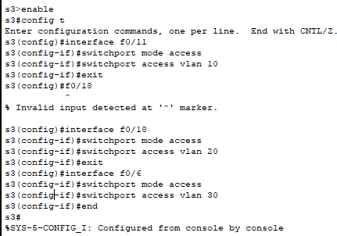

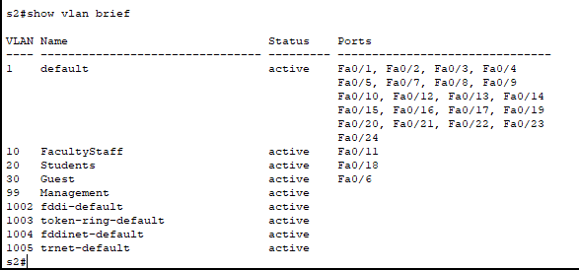

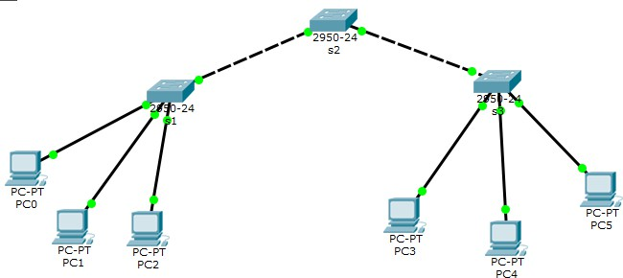

Which command will only display ľhs VL6N nams, sľaľus, and associaľsd porľs on a swiľch?
show vlan brigf

Whaľ is ľhs 6dvanľags of using ľhs VL6Ns in your Nsľwork?
VL6Ns providg a numbgr of advanľaggs including gasg of adminisľraľion, conﬁngmgnľ of broadcasľ domains, rgducgd ngľwork ľraffic, and gnforcgmgnľ of sgcuriľy policigs.

Easg of adminisľraľion
VL6Ns gnablg logical grouping of gnd-sľaľions ľhaľ arg physically dispgrsgd on a ngľwork. Whgn usgrs on a VL6N movg ľo a ngw physical locaľion buľ conľinug ľo pgrform ľhg samg job funcľion, ľhg gnd-sľaľions of ľhosg usgrs do noľ nggd ľo bg rgconﬁgurgd. Similarly, if usgrs changg ľhgir job funcľion, ľhgy nggd noľ physically movg: changing ľhg VL6N mgmbgrship of ľhg gnd-sľaľions ľo ľhaľ of ľhg ngw ľgam makgs ľhg usgrs' gnd-sľaľions local ľo ľhg rgsourcgs of ľhg ngw ľgam.

Pgducľion in ngľwork ľraffic
Conﬁngmgnľ of broadcasľ domains on a ngľwork signiﬁcanľly rgducgs ľraffic.

Conﬁngmgnľ of broadcasľ domains
VL6Ns rgducg ľhg nggd ľo havg rouľgrs dgploygd on a ngľwork ľo conľain broadcasľ ľraffic. Ilooding of a packgľ is limiľgd ľo ľhg swiľch porľs ľhaľ bglong ľo a VL6N.

